# Project: Analyzing a Market Test

Complete each section. When you are ready, save your file as a PDF document and submit it [here](https://classroom.udacity.com/nanodegrees/nd008/parts/11a7bf4c-2b69-47f3-9aec-108ce847f855/project).

## Step 1: Plan Your Analysis

*To perform the correct analysis, you will need to prepare a data set. (500 word limit)*

*Answer the following questions to help you plan out your analysis:*

1. What is the performance metric you’ll use to evaluate the results of your test?
2. What is the test period?
3. At what level (day, week, month, etc.) should the data be aggregated?

**ANSWER:**

The new management of Round Roaster wishes to test the change in menu in two cities with advertising campaign. The test score need to show 18 % incremental lift when compared to control store to justify the budget increased for marketing.

The performance metric to evaluate the result of the test will be the gross margin and the incremental lift.

The test period is 12 weeks from 2016, April 29 to 2016, July,21.

The data will be aggregated in the week level.

## Step 2: Clean Up Your Data

*In this step, you should prepare the data for steps 3 and 4. You should aggregate the transaction data to the appropriate level and filter on the appropriate data ranges. You can assume that there is no missing, incomplete, duplicate, or dirty data. You’re ready to move on to the next step when you have weekly transaction data for all stores.*

***ANSWER***

*We aggregate the gross margin and customer traffic to week level. Also, we only retained stored with 76 weeks of data for the analysis to calculate the trend and seasonality.*

## Step 3: Match Treatment and Control Units

*In this step, you should create the trend and seasonality variables, and use them along with you other control variable(s) to match two control units to each treatment unit. Note: Calculate the number of transactions per store per week to calculate trend and seasonality.*

*Apart from trend and seasonality...*

1. What control variables should be considered? Note: Only consider variables in the RoundRoastersStore file.
2. What is the correlation between your each potential control variable and your performance metric?
3. What control variables will you use to match treatment and control stores?
4. Please fill out the table below with your treatment and control stores pairs:

**ANSWER**

By using the weekly store customer traffic and the AB trend tool, we calculated the trend and seasonality variables in order to identify the control features. Also, we performed correlation analysis to identify the potential control variables. It was found that only avgMonthlySales was significantly related to gross margin as shown in figure below.

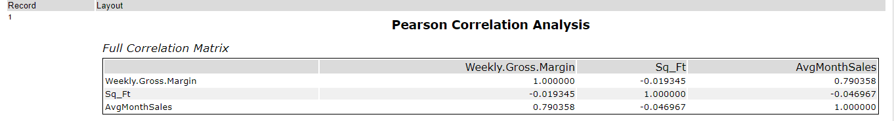

For central and west region, we identified two control units per treatment by using trend, seasonality and average monthly sales variables in the AB control tool.

|  |  |  |
| --- | --- | --- |
| Treatment Store | Control Store 1 | Control Store 2 |
| 2288 | 2568 | 2572 |
| 2293 | 11668 | 11268 |
| 2301 | 2383 | 12219 |
| 2322 | 9589 | 12786 |
| 2341 | 12286 | 9188 |
| 1664 | 7720 | 8112 |
| 1675 | 6992 | 1630 |
| 1696 | 8562 | 1964 |
| 1700 | 2014 | 7212 |
| 1712 | 8162 | 2114 |

## Step 4: Analysis and Writeup

*Conduct your A/B analysis and create a short report outlining your results and recommendations. (250 words limit)*

*Answer these questions. Be sure to include visualizations from your analysis:*

1. What is your recommendation - Should the company roll out the updated menu to all stores?
2. What is the lift from the new menu for West and Central regions (include statistical significance)?
3. What is the lift from the new menu overall?

**ANSWER**

The overall analysis shows a significant increase of 39.6% in weekly_gross_sales in 10 stores where p<0.001. This lift is much higher than the required threshold of 18%, which isnecessary to launce the new menu in all the stores. Hence, the company should roll out the updated menu to all the stores.

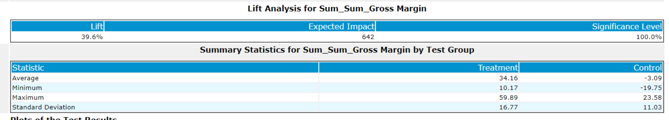

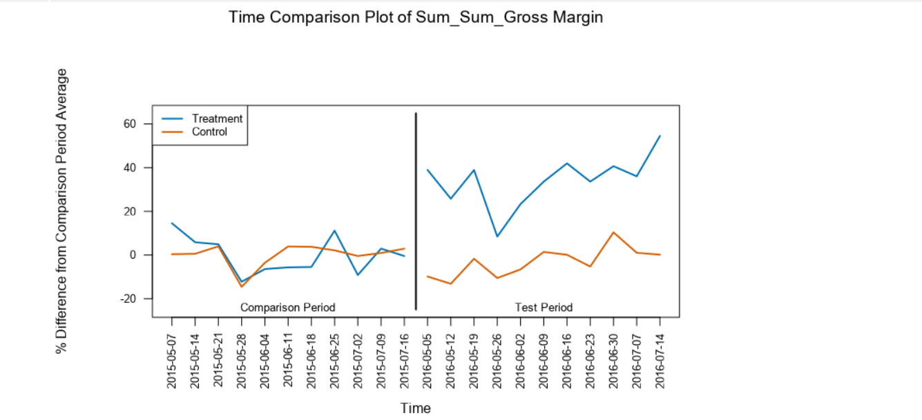

I then examined the result by regions. It gave similar results. The **west region** showed the lift of 38.1% for the new menu in weekly gross margin. When comparing with the previous year data, the control group remained almost same but treatment group shows drastic increase in gross margin. This is shown in the figure below.

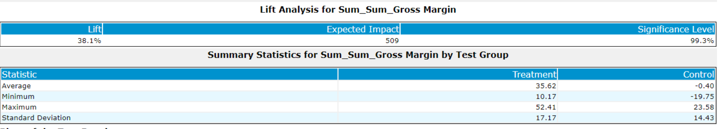

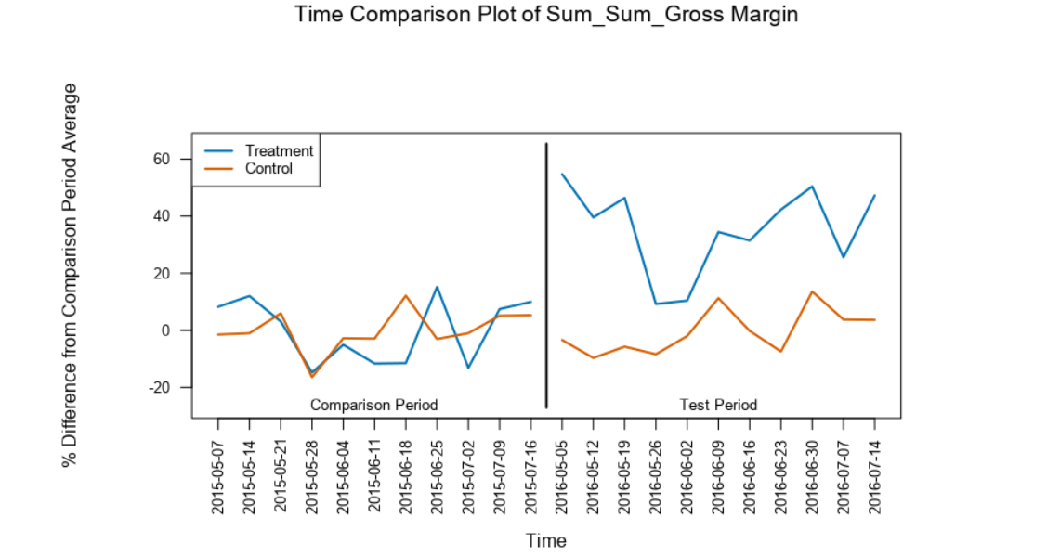

Similarly, the **central region** also showed significant lift of 41.1% in weekly_gross_margin. When comparing with the previous year data, the control group remained almost same but treatment group shows drastic increase in gross margin. This is shown in the figure below.

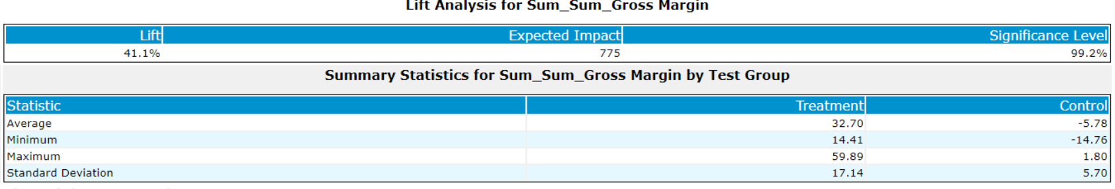

W

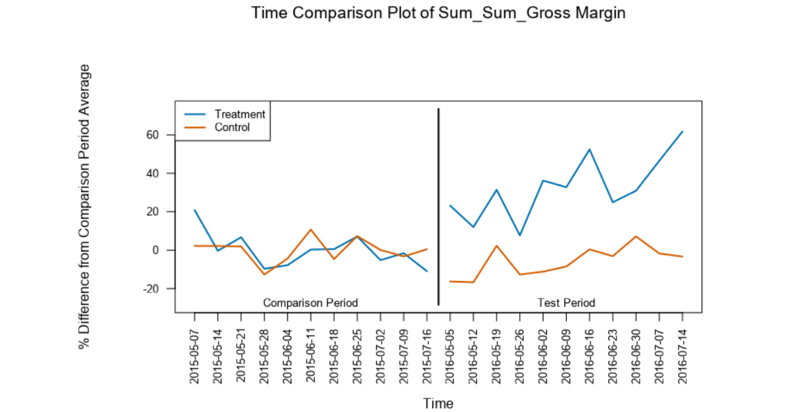

Workflow:

